**1.请求方式为POST，request和response都以json格式存储数据**

http://183.131.144.74:8080/evchong_API/evchong/v1/deviceBoot

RequestBody: {"iccid":{"iccid":"112233"},"chargePointModel":{"chargePointModel":"11"},"chargePointVendor":{"chargePointVendor":"3456"},"chargeBoxSerialNumber":{"chargeBoxSerialNumber":"123456"},"chargePointSerialNumber":{"chargePointSerialNumber":"45678"},"imsi":{"imsi":"xxxxx"},"meterType":{"meterType":"xxxxx"},"firmwareVersion":{"firmwareVersion":"xxxxx"},"meterSerialNumber":{"meterSerialNumber":"xxxxx"}}

ResponseBody: {"currentTime": 1426494920098,"heartbeatInterval": 5,"status": "Rejected"}

http://183.131.144.74:8080/evchong_API/evchong/v1/heartbeat

RequestBody: {"chargePointSerialNumber":{"chargePointSerialNumber":"112233"},"chargeBoxSerialNumber":{"chargeBoxSerialNumber":"33qw34"}}

ResponseBody: {"currentTime": 1425887829034}

http://183.131.144.74:8080/evchong_API/evchong/v1/authorize

RequestBody: {"idToken":{"idToken":"12345"},"chargeBoxSerialNumber":{"chargeBoxSerialNumber":"0004455"}}

ResponseBody: {"idTagInfo": {"expiryDate": 1426494911901,"parentIdTag": {"idToken": "12345"},"status": "Invalid"}}

http://183.131.144.74:8080/evchong_API/evchong/v1/startTrans

RequestBody: {"idTag":{"idToken":"223344"},"connectorId":1,"meterStart":1,"reservationId":1,"chargeBoxSerialNumber":{"chargeBoxSerialNumber":"123456"},"timestamp":1425289031076}

ResponseBody: {"idTagInfo": {"expiryDate": 1426495393825,"parentIdTag": {"idToken": "223344"},"status": "Accepted"},"transactionId": 1}

http://183.131.144.74:8080/evchong_API/evchong/v1/meterValues

RequestBody: {"connectorId":1,"transactionId":1,"chargeBoxSerialNumber":{"chargeBoxSerialNumber":"123456"},"values":[{"measurand":"Energy_Active_Import_Register","unit":"Wh","value":"xxxxx","location":"Outlet","context":"Sample_Periodic","format":"Raw","timestamp":1425289652130}]}

ResponseBody: {"transactionId": 1,"timestamp": 1425888073799}

http://183.131.144.74:8080/evchong_API/evchong/v1/stopTrans

RequestBody: {"idTag":{"idToken":"123456"},"transactionId":1,"transactionData":{"values":{"measurand":"Energy_Active_Import_Register","unit":"Wh","value":"xxxxxx","location":"Outlet","context":"Sample_Periodic","format":"Raw","timestamp":1425886218825}},"chargeBoxSerialNumber":{"chargeBoxSerialNumber":"445566"},"meterStop":1,"timestamp":1425886218829}

ResponseBody: {"idTagInfo": {"expiryDate": 1426495476678,"parentIdTag": {"idToken": "123456"},"status": "Accepted"},"transactionId": 1}

http://183.131.144.74:8080/evchong_API/evchong/v1/statusNotify

RequestBody: {"connectorId":1,"vendorErrorCode":"1122","chargeBoxSerialNumber":{"chargeBoxSerialNumber":"123456"},"errorCode":"GroundFailure","vendorId":"4455","info":"xxxxx","timestamp":1425290540330,"status":"Available"}

ResponseBody: {"timestamp": 1425888213256}

**2.我们目前使用SoapUI 5.0.0进行调试:**

安装完成后，可以直接导入我们的project，File -> Import Project，

导入工程后，打开如下所示：

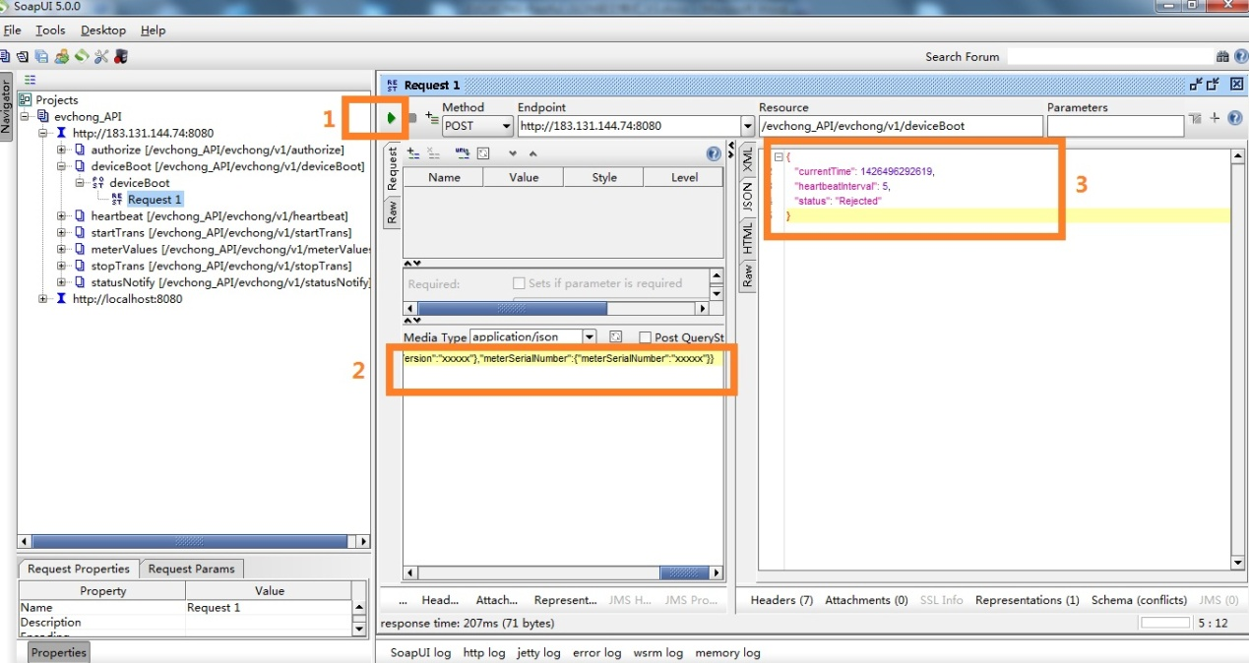

例如打开deviceBoot下面的Request 1，点击“1”红框里面的绿色箭头，即执行这个request请求，将“2”红框部分的json作为request body提交到服务端，服务端返回的response body的json会显示在“3”红框部分。